Comsats university Islamabad, Abbottabad campus



Software Design and Architecture

Lab Assignment 01

Name: Waqas Ahmed (FA22-BSE-009)

Submitted To: **Mukhtiar Zamin**

Submission Date: 07-nov-2024

Module Name: Submit Assignment

**Project Overview:**

The software is a university portal is a web-based application designed to provide students with essential academic functionalities in one place. The objective of this project is to create a centralized platform where students can access their courses, view assignments, check semester results, and take online exams.

**Modules:**

* **Course Content**: This module allows students to access their course materials, including lectures, PDFs.
* **Assignment Summary**: In this module, students can view detailed information about their assignments, including deadlines and submission status.
* **Semester Results**: This feature provides students with a consolidated view of their semester results.
* **Online Exam**: This module facilitates the scheduling and management of online exams, allowing students to attend them through the portal.

**Use Case Diagram:**

* **Actors**:
  + **Student**: Uses the portal to access course content, view results, and take exams.
  + **Admin/Teacher**: Responsible for uploading course content, setting assignments, and updating results.
* **Main Use Cases**:
  + **Access Course Content**: Students can view their course materials.
  + **Submit Assignment**: Students submit their assignments and track submission status.
  + **View Results**: Students view their semester-wise results.
  + **Take Online Exam**: Students take their scheduled exams online.

**Use case diagram: University portal:**

**Code of above diagram:**

public class UniversityPortal {

public static void main(String[] args) {

Student student = new Student();

Teacher teacher = new Teacher();

// Student interactions

student.login();

student.accessCourseContent();

student.submitAssignment();

student.viewResult();

student.takeOnlineExam();

// Teacher interactions

teacher.login();

teacher.uploadCourseContent();

teacher.setAssignment();

teacher.setQuiz();

}

}

// Student class with relevant methods

class Student {

public void login() {

System.out.println("Student logged in to the university portal.");

}

public void accessCourseContent() {

System.out.println("Student accessed course content.");

}

public void uploadCourseContent() {

System.out.println("Student uploaded course content.");

}

public void submitAssignment() {

System.out.println("Student submitted assignment.");

}

public void viewResult() {

System.out.println("Student viewed result.");

}

public void takeOnlineExam() {

System.out.println("Student took online exam.");

}

}

// Teacher class with relevant methods

class Teacher {

public void login() {

System.out.println("Teacher logged in to the university portal.");

}

public void accessCourseContent() {

System.out.println("Teacher accessed course content.");

}

public void uploadCourseContent() {

System.out.println("Teacher uploaded course content.");

}

public void setAssignment() {

System.out.println("Teacher set assignment.");

}

public void setQuiz() {

System.out.println("Teacher set quiz.");

}

}

**SSD: Submit Assignment (as I selected submit assignment module)**

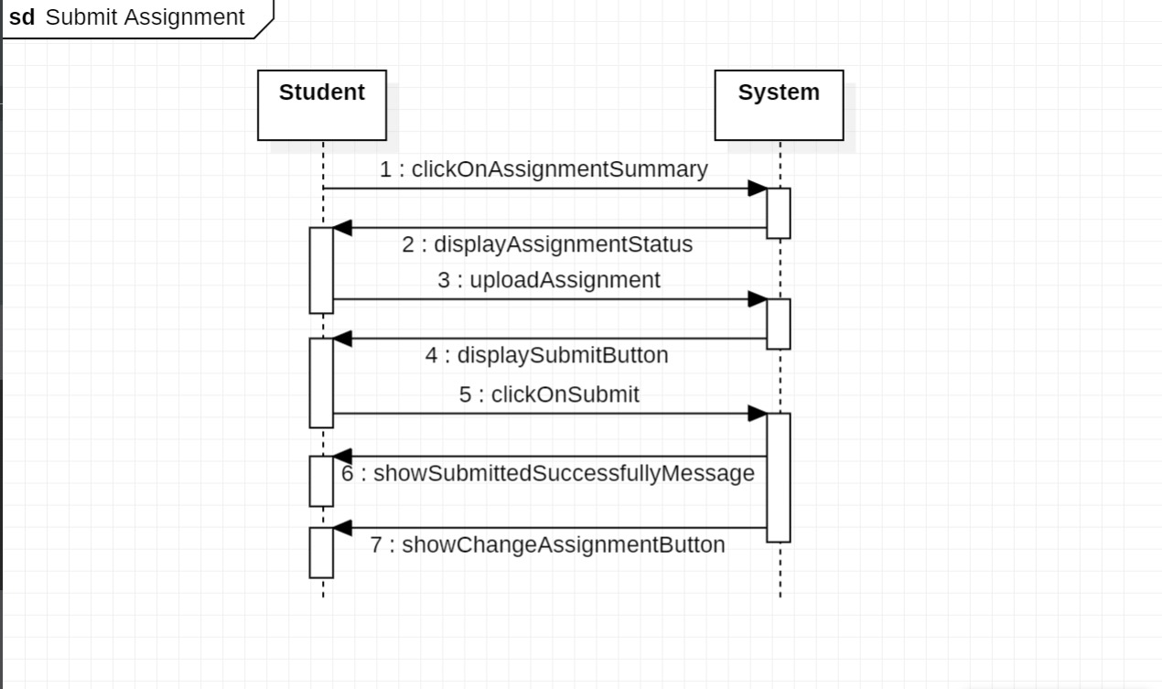

**Code of above diagram:**

class AssignmentSystem {

public void displayAssignmentStatus() {

System.out.println("System displays assignment status.");

}

public void displaySubmitButton() {

System.out.println("System displays submit button.");

}

public void showSubmittedSuccessfullyMessage() {

System.out.println("System shows 'Submitted Successfully' message.");

showChangeAssignmentButton();

}

public void showChangeAssignmentButton() {

System.out.println("System displays 'Change Assignment' button.");

}

}

class Student {

AssignmentSystem assignmentSystem;

public Student(AssignmentSystem assignmentSystem) {

this.assignmentSystem = assignmentSystem;

}

public void clickOnAssignmentSummary() {

System.out.println("Student clicked on assignment summary.");

assignmentSystem.displayAssignmentStatus();

}

public void uploadAssignment() {

System.out.println("Student uploaded the assignment.");

assignmentSystem.displaySubmitButton();

}

public void clickOnSubmit() {

System.out.println("Student clicked on submit.");

assignmentSystem.showSubmittedSuccessfullyMessage();

}

}

public class SubmitAssignment {

public static void main(String[] args) {

AssignmentSystem assignmentSystem = new AssignmentSystem();

Student student = new Student(assignmentSystem);

student.clickOnAssignmentSummary();

student.uploadAssignment();

student.clickOnSubmit();

}

}

**Communication diagram: Submit Assignment**

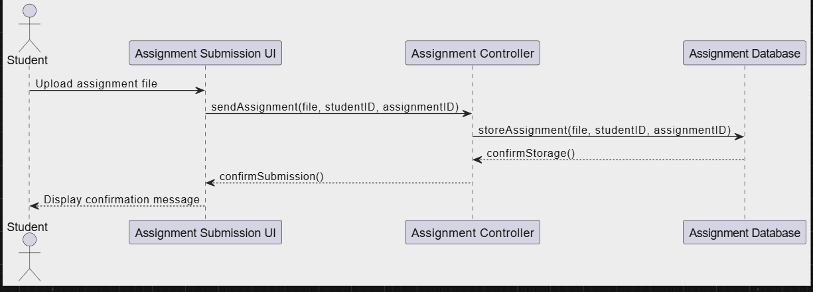

**Code of above diagram:**

class Student {

public void uploadAssignmentFile(String file, String studentID, String assignmentID) {

System.out.println("Student uploads assignment file.");

AssignmentSubmissionUI ui = new AssignmentSubmissionUI();

ui.sendAssignment(file, studentID, assignmentID);

}

}

class AssignmentSubmissionUI {

public void sendAssignment(String file, String studentID, String assignmentID) {

System.out.println("AssignmentSubmissionUI sends assignment to AssignmentController.");

AssignmentController controller = new AssignmentController();

controller.storeAssignment(file, studentID, assignmentID);

}

public void displayConfirmationMessage() {

System.out.println("AssignmentSubmissionUI displays confirmation message to the student.");

}

}

class AssignmentController {

public void storeAssignment(String file, String studentID, String assignmentID) {

System.out.println("AssignmentController stores assignment in AssignmentDatabase.");

AssignmentDatabase database = new AssignmentDatabase();

database.storeAssignment(file, studentID, assignmentID);

confirmSubmission();

}

public void confirmSubmission() {

System.out.println("AssignmentController confirms submission to AssignmentSubmissionUI.");

AssignmentSubmissionUI ui = new AssignmentSubmissionUI();

ui.displayConfirmationMessage();

}

}

class AssignmentDatabase {

public void storeAssignment(String file, String studentID, String assignmentID) {

System.out.println("AssignmentDatabase stores the assignment details.");

}

}

public class SubmitAssignment {

public static void main(String[] args) {

Student student = new Student();

student.uploadAssignmentFile("AssignmentFile.pdf", "12345", "A01");

}

}

**Communication Diagram of Submit assignment**

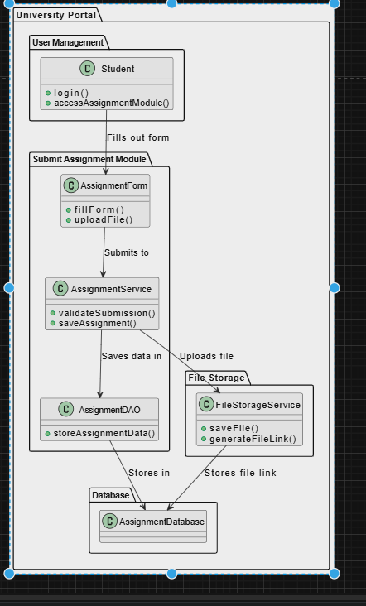

**Code is below:**

public class SubmitAssignment {

public static class Student {

public void login() {

System.out.println("Student logged in.");

}

public void accessAssignmentModule() {

System.out.println("Student accessed the Assignment Module.");

}

}

// Submit Assignment Module package

public static class AssignmentForm {

public void fillForm() {

System.out.println("Filling out the assignment form.");

}

public void uploadFile() {

System.out.println("Uploading assignment file.");

}

}

public static class AssignmentService {

private AssignmentDAO assignmentDAO = new AssignmentDAO();

private FileStorageService fileStorageService = new FileStorageService();

public void validateSubmission() {

System.out.println("Validating assignment submission.");

}

public void saveAssignment() {

System.out.println("Saving assignment data.");

assignmentDAO.storeAssignmentData();

fileStorageService.saveFile();

}

}

public static class AssignmentDAO {

public void storeAssignmentData() {

System.out.println("Storing assignment data in database.");

}

}

// File Storage package

public static class FileStorageService {

public void saveFile() {

System.out.println("Saving file to storage.");

}

public void generateFileLink() {

System.out.println("Generating file link.");

}

}

// Main method to demonstrate functionality

public static void main(String[] args) {

// Creating instances

Student student = new Student();

AssignmentForm form = new AssignmentForm();

AssignmentService service = new AssignmentService();

// Simulating the submit assignment process

student.login();

student.accessAssignmentModule();

form.fillForm();

form.uploadFile();

service.validateSubmission();

service.saveAssignment();

}

}